Introduction
In order to establish a connection, it is important to recognise that humans are inherently social beings. Establishing strong interpersonal connections is essential. Communication serves the dual purpose of establishing and cultivating mutually advantageous relationships.
Defining Identity
Identity refers to our sense of who we are as individuals and as members of social groups. It also refers to our sense of how others may perceive and label us from different sources such as our family and friends, our schools and other institutions, the mass media, and our encounters with other individuals.
The constant process of establishing your image (identity) or impression in the mind of others about yourself is none other than personal branding.
Developing a powerful Personal Brand is extremely important, as it is the gateway of making your place in society. When you develop a strong personal brand it becomes easy for people to remember you when promotions or awards are handed out.
How to develop a powerful personal brand?
- Ask yourself the question: What do I want my key stakeholders to say about me when I'm not in the… This description is your desired professional brand.
- Likewise, you might also ask yourself in another way: What would I care about that my key stakeholders might say about me when I'm not in the… The answer to this question is your undesired professional image.
ACCEPT
- If you don’t form your own PROFESSIONAL IMAGE - others will form it for you.
- Better to control your own image.
OBSERVE
- Fact that people are OBSERVING your BEHAVIOUR & ACTIONS – they will form their OPINIONS about your CHARACTER.
WORK AT IT
- Your ACTIONS over a period of time will spread – people will form the RIGHT IMAGE of you.
STEPS
What are the steps individuals should take to manage their professional brand?
- Accept that if you aren't managing your own professional image, someone else is in the form of the way they respond to you. So, it is in your best interest to be in control of your personal brand.
- Observe the fact that people are observing your behaviour and actions and are forming opinions about your competence, character, and commitment.
- Work at it constantly. Through digital media and physical contact, your actions over a period of time spread the word about you and people begin to form the right impression of you. You can do it by doing a SWOC analysis.

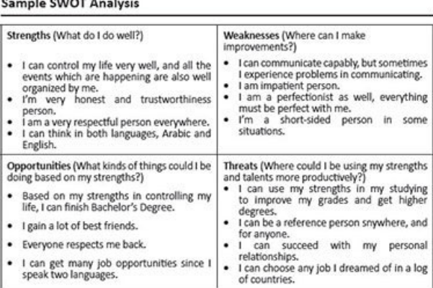
Relationship between self-esteem and self-image
♦ SELF-IMAGE: The way we see ourselves.
♦ SELF-ESTEEM: The way we feel about ourselves.
♦ SELF CONFIDENCE: Belief about our ability, capability and potential.
Low Self-Esteem: Poor Self-Image caused by ATTITUDE.
High Self-Esteem: Confident, Happy, Sure of yourself.
Self-Image (⬆️) Personal Brand (<<💪)
Courage and Self Confidence (🛠️)
Your first impression is very important and you get only one chance to make a powerful impact.
Low self-esteem results from you having a poor self-image caused by your attitude, if you have high self-esteem, you will be confident, happy and sure of yourself. Your self-image will go up and your personal brand will become more powerful. You can develop the courage and self-confidence to overcome any adversity of life.
Ways to build self-esteem and confidence
- Acknowledge/Accept yourself
- Avoid negative thoughts
- Be assertive
- Learn from your mistakes
- Practice gratitude
- Set goals for yourself
- Stay strong and confident
- Say positive affirmations

